**Monitoring Lab 5 Report**

YI WANG 3371561

**Task 1**

**Create a project, generate two epochs, perform individual adjustments for each epoch and optimize the accuracy level.**

We first open ‘PANDA’ program, create new project, set file path, and choose coordinate systems. Then we import all ‘datum point’ data, generate epoch 2003 and 2012, reduce and perform individual adjustment for each epoch.

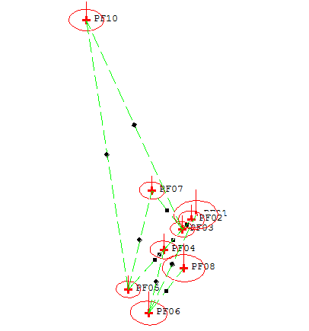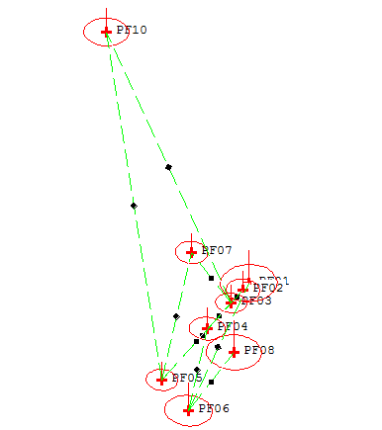

Fig 1. Adjustments for epoch 2003 (left) and 2012 (right)

**Task 2**

**Perform a deformation pre-analysis using the adjusted epochs 1 and 2, print the results and interpret them. What is the purpose of the adjustment of the individual epochs?**

By performing ‘New Deformation Analysis’ we start deformation analysis, the pre-analysis of which is shown in Fig 2. From the ‘default.prt’ file we can see that both datum are free networks, with datum defect for translation in three directions, which is verified by the null hypothesis testing.

The purpose of the adjustment of the individual epochs is to improve the accuracy of the values, detect the gross errors in the observation and adapt the pre-given level of required accuracy.

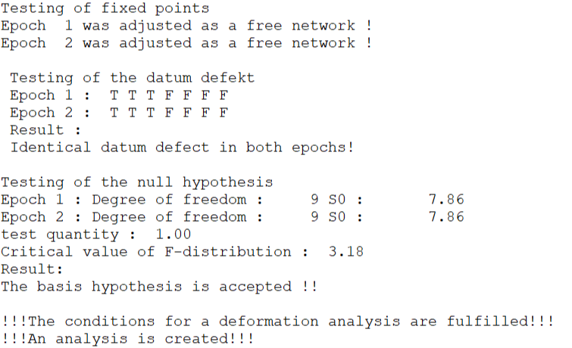

Fig 2. Default.prt

**Task 3**

**Perform the deformation analysis and interpret the results. Which results does the analysis provide? Which points have changed their position?**

We first set the fields ‘Dual stage analysis’, ‘Storage of results’ and ‘Extended output-list’, and then perform the deformation analysis. From the output document ‘2003vs2012.o3d’, we get information shown as follows:

* 9 identical points are all reference points, with a standard deviation of 1.00 and datum defect 3 in 3 translation directions
* Specific information about output of selected options:

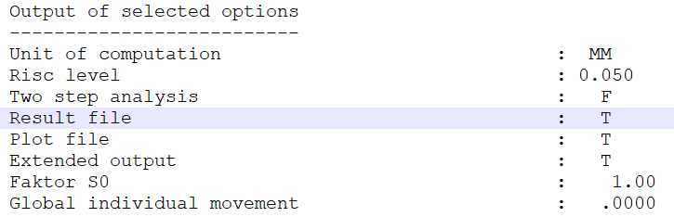

Fig 3. Output characteristics of selected options

* Detailed coordinates information of the two epochs:

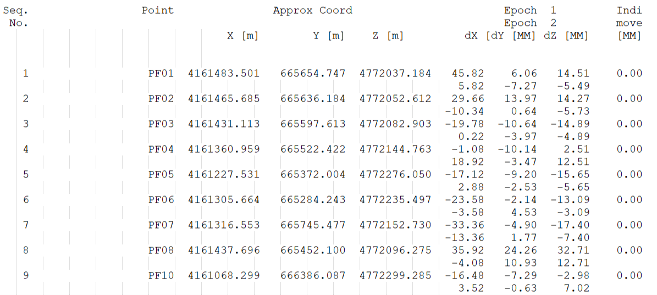

Fig 4. Detailed coordinate information

* Results of ‘Backward strategy’ for all points, with an initial assumption of no significant movements (H0) which is rejected in this case. With localization in the next step, the first moving point (P2) is found and removed. Similarly, all three moving points (1, 2 and 8) are found and removed, leading to the acceptation of the H0 assumption finally.

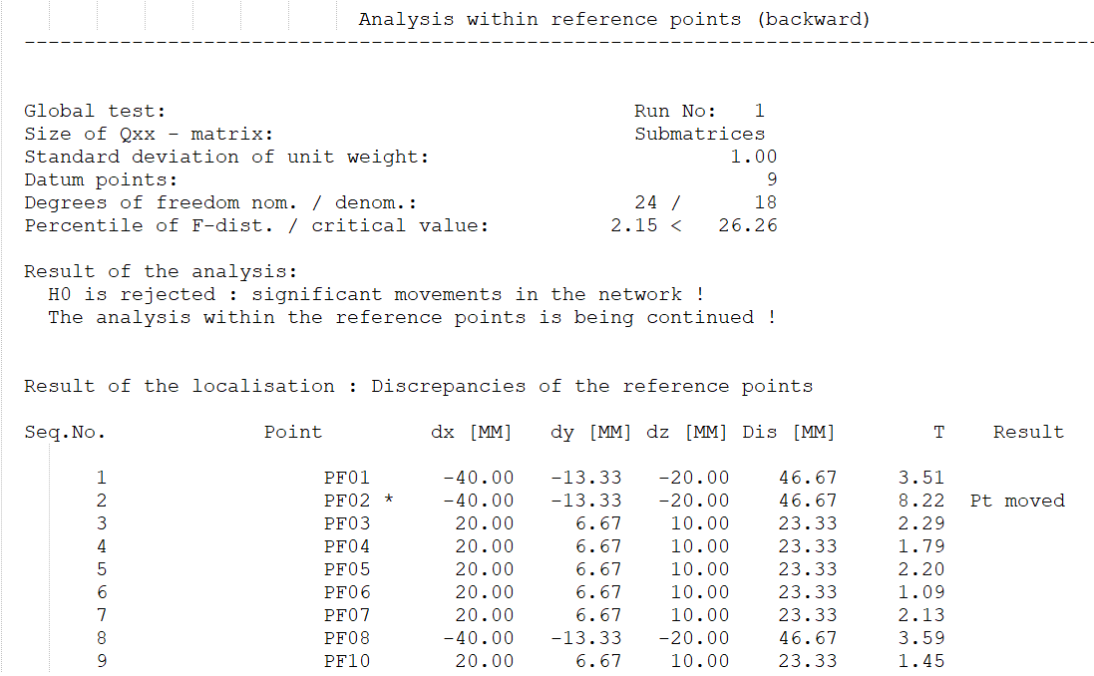

Fig 5. The first moving point (P2)

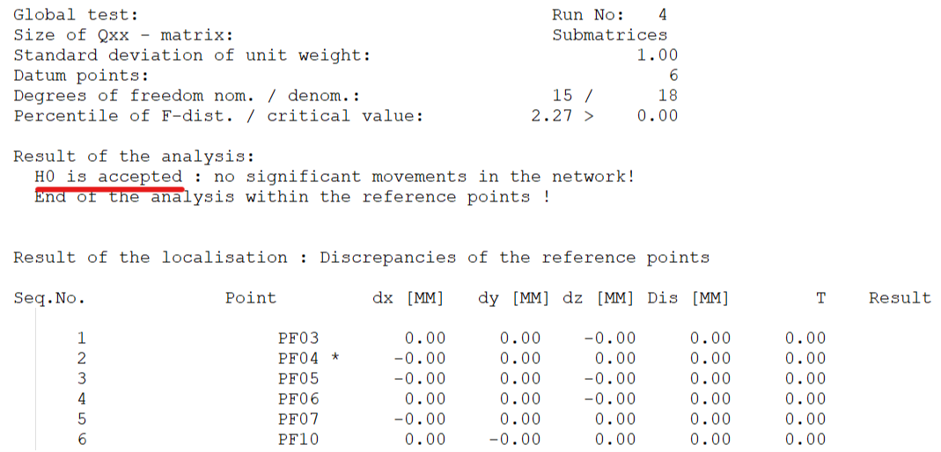

Fig 6. Final acceptation of H0

* Results of ‘Forward Strategy’ by setting the 3 moving points as object points, which show obviously that with these three points, the initial assumption H0 is rejected again.

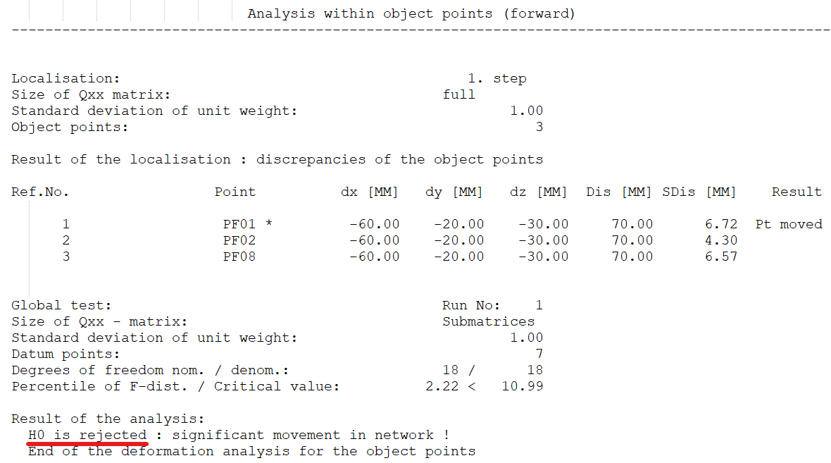

Fig 7. Forward Strategy

* Results of discrepancies and precision of both global and local on both object points (point 1, 2 and 8) and reference points (the other points)

To sum up, Point 1, 2 and 8 have changed their positions.

**Task 4**

**Calculate a new adjustment for each epoch where the 3 moving points are not used.**

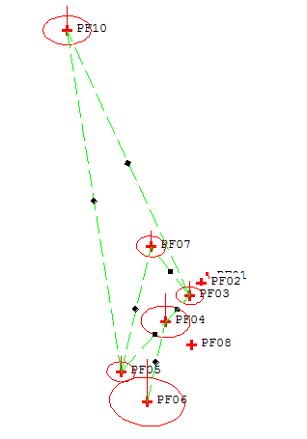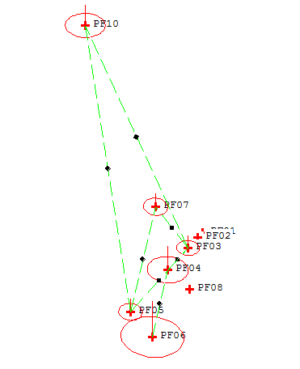

Fig 8. Adjustments for epoch 2003 (left) and 2012 (right) after removing points

**Task 5**

**Create a new deformation analysis and repeat steps from Task 3, interpret the results and describe the differences with respect to Task 3.**

The new deformation analysis results are shown in the output document ‘2003vs2012-2.o3d’, most of which remain the same as in Task 3. The differences are:

* This time there are 6 identical points, the detailed information of which changes with respect to Task 3
* The initial assumption H0 (no movement) is accepted because the three moving points have been removed
* Test quantity, precision and discrepancies change a little bit

**Task 6**

**Export the net graphics and mark the points for which movements between the epochs can be proved. Specify the movement values and interpret the situation in the measurement area.**

The graphics of adjusted network 2003 and 2012 with and without moving points have been shown in Task 1 and Task 5. The graphics of deformation analysis with and without moving points are shown as follows:

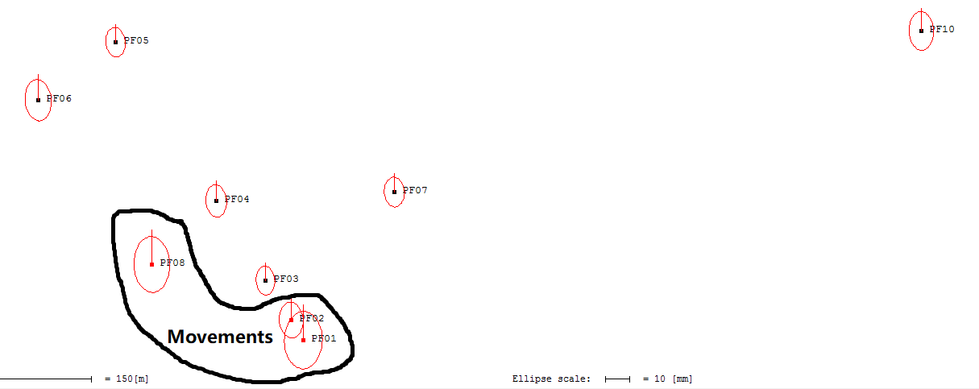

Fig 9. 2003vs2012

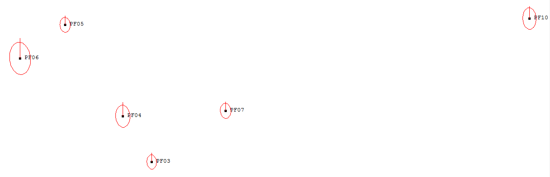

Fig 10. 2003vs2012-2

By calculating the coordinate differences of epoch 2003 and 2012 (i.e. the discrepancies) we get the same movement values both in global and local coordinates, which shows that the movements of points will not change by the change of coordinate system.

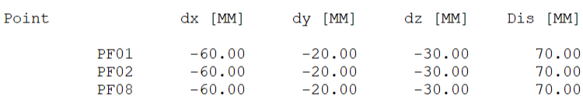

Fig 11-1. Movements in global coordinates

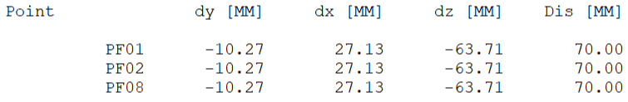

Fig 11-2. Movements in local coordinates